***Lab 2 – Introduction to MVC and Routing***

*Follow the steps:*

*Create a New MVC Application:*

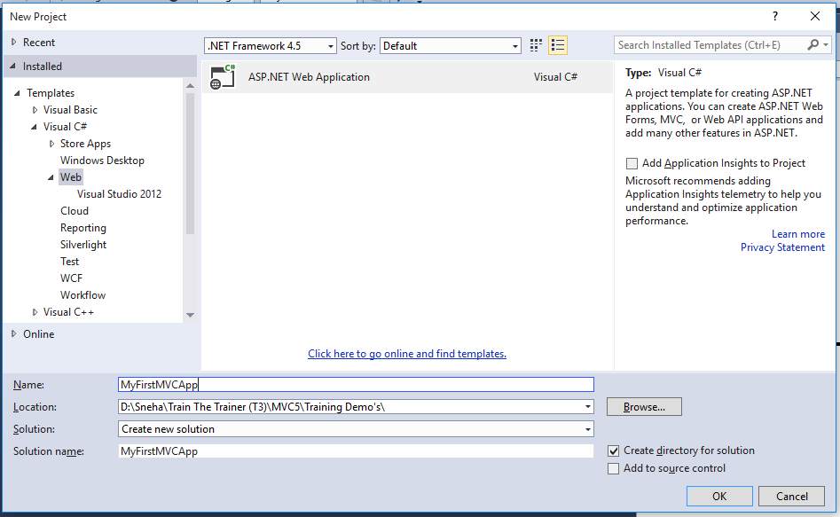

*Clcik on Ok. The following Window will open:*

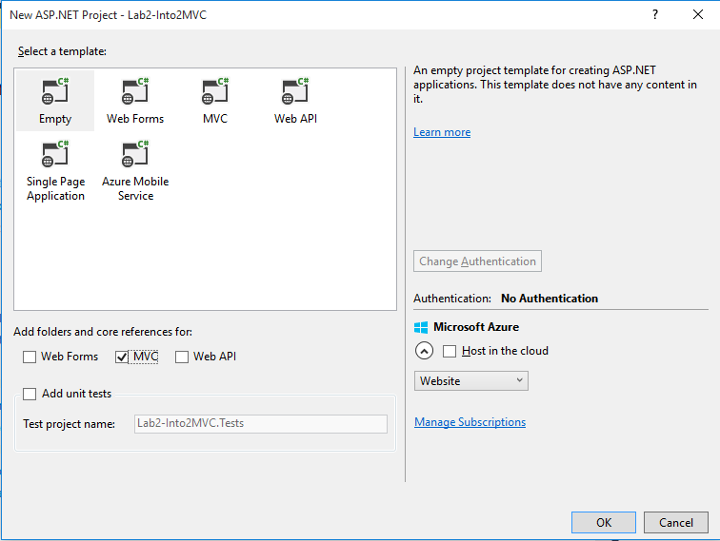

*Click on Empty > Check MVC checkbox > Click on OK. The following will appear in the Solution Explorer:*

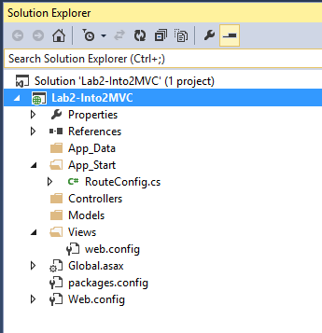

*Right Click on Controllers Folder > Add > Controller. Select MVC 5 Empty Controller.*

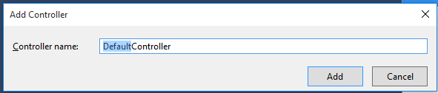

*Change the Default word to Home. Create a new Method as follows:*

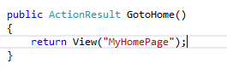

*Right click on Home Folder under Views Folder*

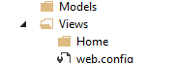

*Click on Add > View. The following window will open:*

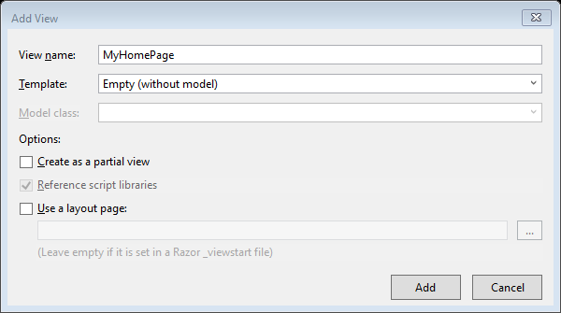

*Change the View Name to “MyHomePage” > uncheck the Use a layout Page checkbox > click Add button*

*Write the following code in the View:*

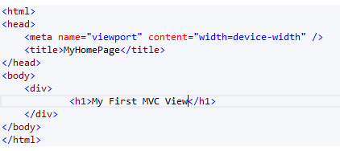

*Execute the code. It will give you error “Resource not found”. Change the URL as follows:*

**

*Now you would be able to View the page:*

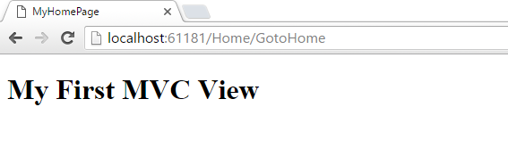

*Managing Routes in MVC*

*When we want to call the MyHomePage View with the following URL:*

**

*Add the following code snippet in RouteConfig.cs*

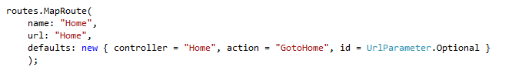

*When we want to call the MyHomePage View with the following URL:*

**

*Add the following code snippet in RouteConfig.cs*

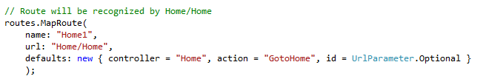

*Setting a default View in MVC Application*

